**HAPPY SUMMER!**

**Schools Out For Summer!!!**

**Family First Fostering would like to wish you all a Happy Summer 2018!**

**CONTENT**

* **General Updates**
* **Activities for children**
* **Brainteasers**
* **Recipes for kids**
* **Summer tips**



**GENERAL UPDATE**



**New Staff**

**SUMMER FUN!**

We would like to welcome Caleb our new Supervising Social Worker and Fabiha our new Administrator. We welcome you to the team and look forward to working with you both.

**Jurassic Falls Adventure Golf**

**Woburn Safari**

**Fruit Picking**

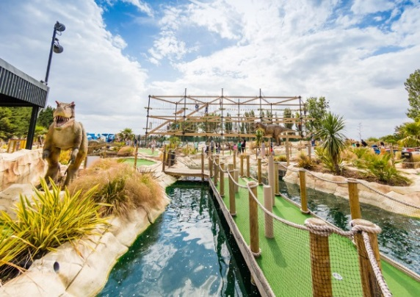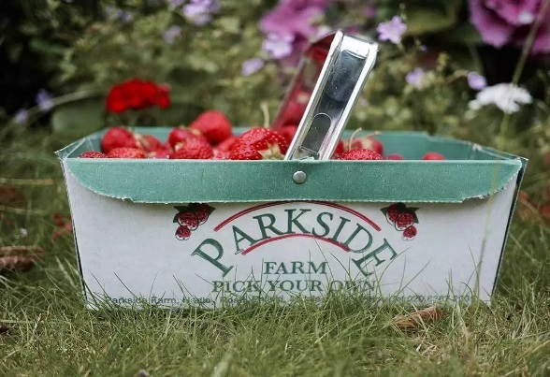

**Hoa in the Snow at Warner Bros. Studio Tour L**

***Enjoy a day around the course with your family. The Jurassic Falls golf course contains a full 18 holes of educational adventure, life-size dinosaurs that move and roar, a breath-taking waterfall and bright-blue lagoon.***

**Location:**

**Southend Road, Walthamstow, London E4 8TA**

**Dates:**

**August: 9-7pm Last admission: 6:15pm**

**September: 11-6pm Last admission: 5:15**

***Have a fun day out in the beautiful countryside picking up your very own fruits and vegetables. Strawberries, Raspberries, Sweetcorn, Blackberries, Blackcurrants, Redcurrants, French Beans, Courgettes, Beetroot, Spinach, Swiss Chard, Green Onions & Marrows, it’s as fresh as it gets.***

**Location:**

**Parkside Farm, Hadley Road, Enfield, Middlesex, EN2 8LA**

**Dates:**

**Tuesday-Saturday: 9am-5.30pm Last admission: 4:30**

**Sunday: Variable**

***Enter a land of adventure where lions roam, monkeys swing and tigers stalk. Woburn is a wildlife park consisting of 1000 animals in a road safari and foot safari. The park has a 40-acre leisure area including animal talks, petting zones, a gift shop, family restaurant and a Go Ape!***

**Location:**

**Woburn, Bedford MK17 9QN**

**Dates:**

**OPEN DAILY from 10am to 5pm until 14th October*.***

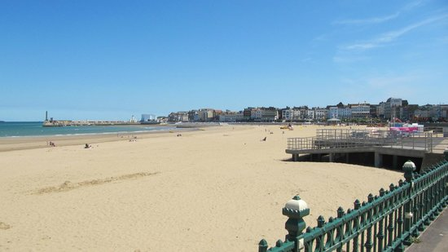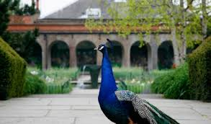**SPOT THE D****IFFER****ENCE**

**Science Museum**

***Six floors of exhibits on energy, environment, space, and transport, which makes it an ideal location for a day-long visit.*** ***There’s plenty to see for children and adults alike at the Science Museum.***

**Location:**

**Exhibition Rd, London SW7 2DD**

**Dates:**

**Open every day 10am-6pm**

**FREE ENTRY**

**Holland Park**

***Margate's central beach offers visitors an award-winning wide, sandy stretch backed by a traditional seaside resort. A boardwalk gives easy access to the beach and is the perfect spot to while away a sunny afternoon while young visitors enjoy splashing at the water's edge and playing in the sand. Older children may enjoy a trip to Dreamland - Margate's iconic theme-park!***

**Location:**

**Marine Terrace, Margate, Kent, CT9 1XJ, England**

**Dates:**

**Year-round access**

***The Royal Borough’s largest park consisting of gardens, children’s play facilities, sports areas, a cafeteria and large areas of woodland with wildlife. Holland Park provides facilities for tennis, football, golf practice nets, cricket practice nets and netball.***

**Location:**

**Ilchester Pl, Kensington, London W8 6LU**

**Dates:**

**The park is open daily from 7.30am until 30 minutes before dusk.**

**FREE ENTRY**

**Margate Beach**

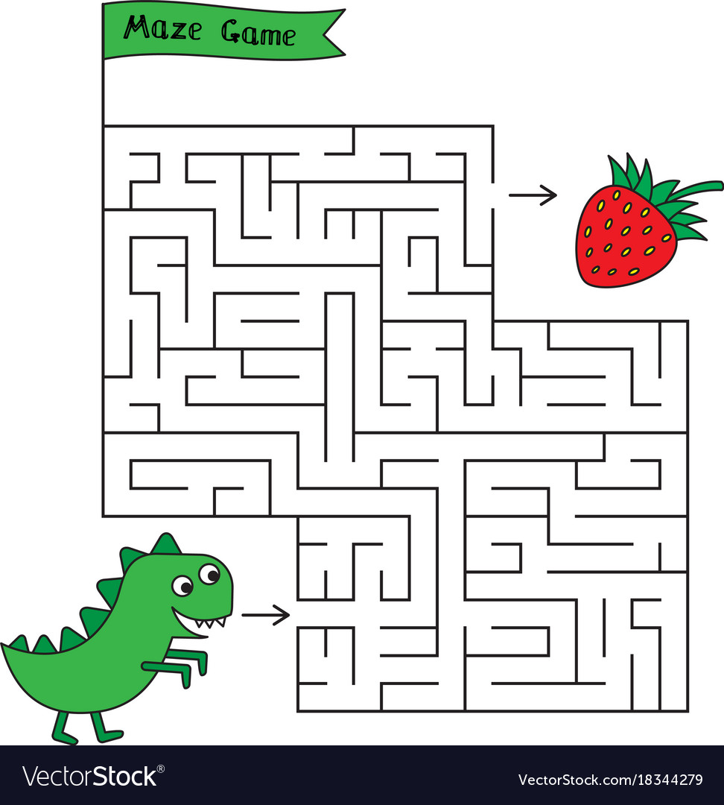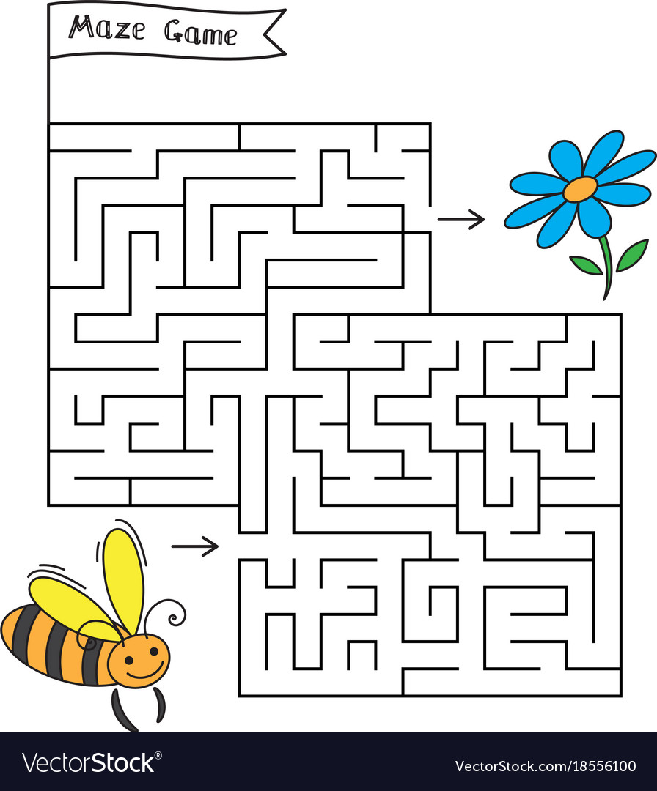

**MAZE GAME**

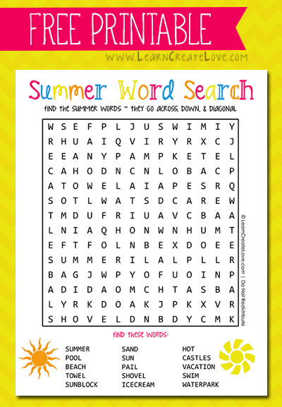

**SUMMER WORDSEARCH**

**I**

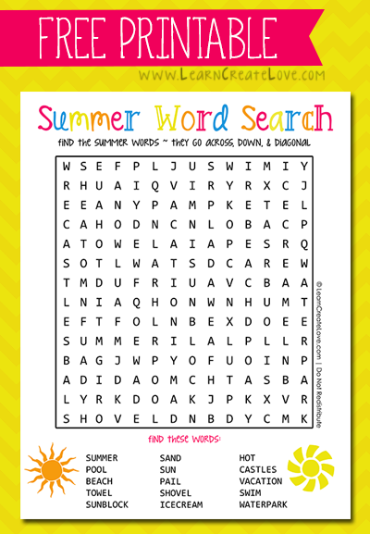

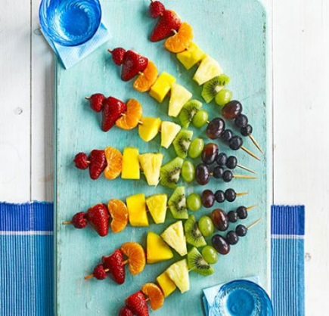

**Method:**

Take 7 wooden skewers and thread the following fruit onto each – 1 raspberry, 1 hulled strawberry, 1 tangerine segment, 1 cube of peeled mango, 1 chunk of peeled pineapple, 1 chunk of peeled kiwi, 1 green and 1 red grape, and finish off with 2 blueberries. Arrange in a rainbow shape and let everyone help themselves.

**Ingredients:**

**SERVES 7**

7 raspberries 7 hulled strawberries 7 tangerine segments 7 cubes peeled mango 7 peeled pineapple chunks 7 peeled kiwi fruit 7 green grapes 7 red grapes 14 blueberries

**These vitamin-packed fruit skewers are a simple, colourful and fun way to get kids to eat fruit. They'll love helping to make them too.**

**TASTY TREATS TO ENJOY THIS SUMMER**



**This Oreo milkshake can be made in under 10 minutes with only 3 ingredients!**

**Method:**

Blend ice cream, milk and chocolate cookies together in a blender until smooth. Pour into 2 glasses.

**Ingredients:**

**Serves: 2**

3 scoops vanilla ice cream 180ml milk 6 chocolate sandwich cookies (such as Oreos)

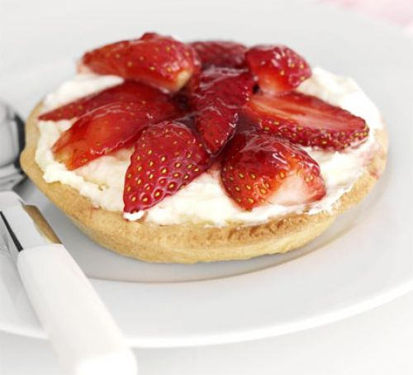

**INGREDIENTS:**

350g ready-made sweet shortcrust pastry flour for rolling out 150ml double cream 1 tbsp lemon curd ½ punnet strawberries 2 tbsp strawberry jam, without any whole strawberries

**STRAWBERRY TARTS**

**Get the kids in the kitchen to create these teatime treats, perfect to show off their cooking skills**

**METHOD:**

**1.**Turn the oven to 180C/fan 160C/gas 4. Roll the pastry out on a floured surface until it’s as thick as £1 coin. Cut round a saucer to make 4 circles. Put each one into the tin. **2.** Put a square of greaseproof paper and some rice in each. Ask a grown-up to put them in the oven for 25 minutes, then take paper and rice out. Leave to cool. **3.** Use a whisk to whisk the cream until it starts to get thick, then stir in the lemon curd. **4.** Pull the green hulls out of the strawberries and cut each one carefully into slices with a small knife. **5.** Spoon the cream into 4 pastry cases. Arrange the strawberry slices in a spiral or in rows on top of the lemon cream. **6.** Mix the jam in a bowl with 1 tbsp hot water, then brush it over the strawberries.

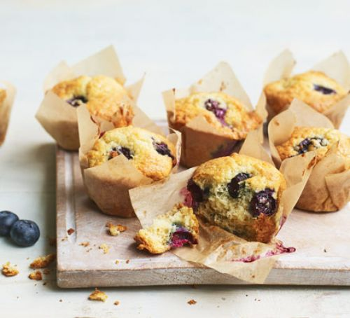

**METHOD:**

**1.**Heat oven to 200C/180C fan/gas 6 and line a 12-hole muffin tin with paper cases **2.** Beat the butter and caster sugar together until pale and fluffy. **3.** Add the eggs and beat in for 1 min, then mix in the yogurt, vanilla extract and milk. **4.** Combine the flour, baking powder and bicarb in a bowl with 1/4 tsp fine salt, then tip this into the wet ingredients and stir in. **5.** Finally, fold in the blueberries and divide the mixture between the muffin cases**. 6.** Bake for 5 mins, then reduce oven to 180C/160C fan/gas 4 and bake for 15-18 mins more until risen and golden, and a cocktail stick inserted into the centre comes out clean. **7.** Cool in the tin for 10 mins, then carefully lift out onto a wire rack to finish cooling. Will keep for 3-4 days in an airtight container – after a day or two, pop them in the microwave for 10-15 secs on high to freshen up.

**Make these super easy blueberry muffins for a fun summer bake. You're just a few simple steps away from bite-sized blueberry treats**

Blueberry Muffins

**INGREDIENTS:**

100g unsalted butter softened, plus 1 tbsp, melted, for greasing 140g golden caster sugar 2 large eggs 140g natural yogurt 1 tsp vanilla extract 2 tbsp milk 250g plain flour 2 tsp baking powder 1 tsp bicarbonate of soda 125g pack blueberries (or use frozen)

1 tsp bicarbonate of soda

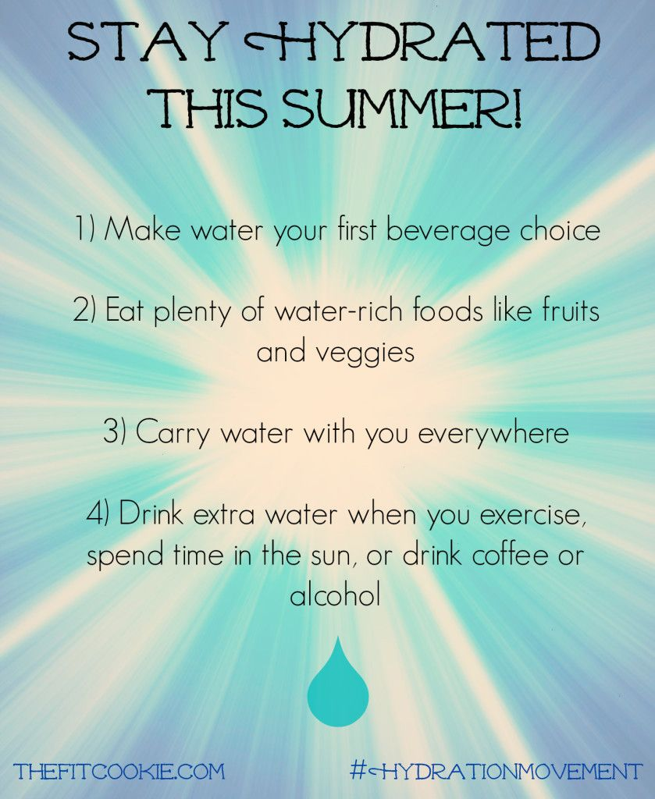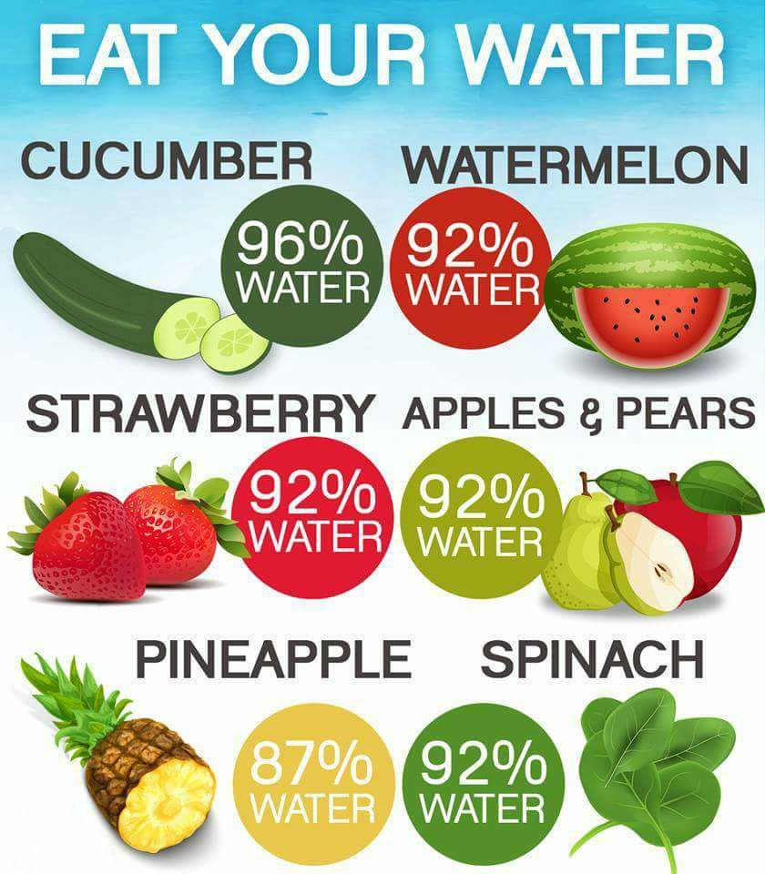**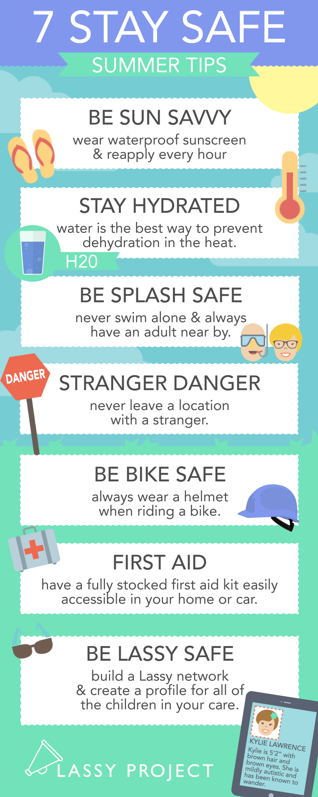SUMMER TIPS**